**Inter Process Communication-Pipes**

**LAB # 10**



**Spring 2022**

**Operating System**

**Submitted by:**

**Maaz Habib,Alishba Orakzai, Nida Asmat Burki**

**Reg no.:**

**20PWCSE1952,20pwcse1953 , 20pwcse1955**

**Class Section:**

**C**

“On my honor, as student of University of Engineering and Technology, I have neither given nor received unauthorized assistance on this academic work.”

Submitted to:

**Engr Mian Ibad**

July 03, 2022

**Department of Computer Systems Engineering**

**University of Engineering and Technology, Peshawar**

**Task1:**

**Code:**

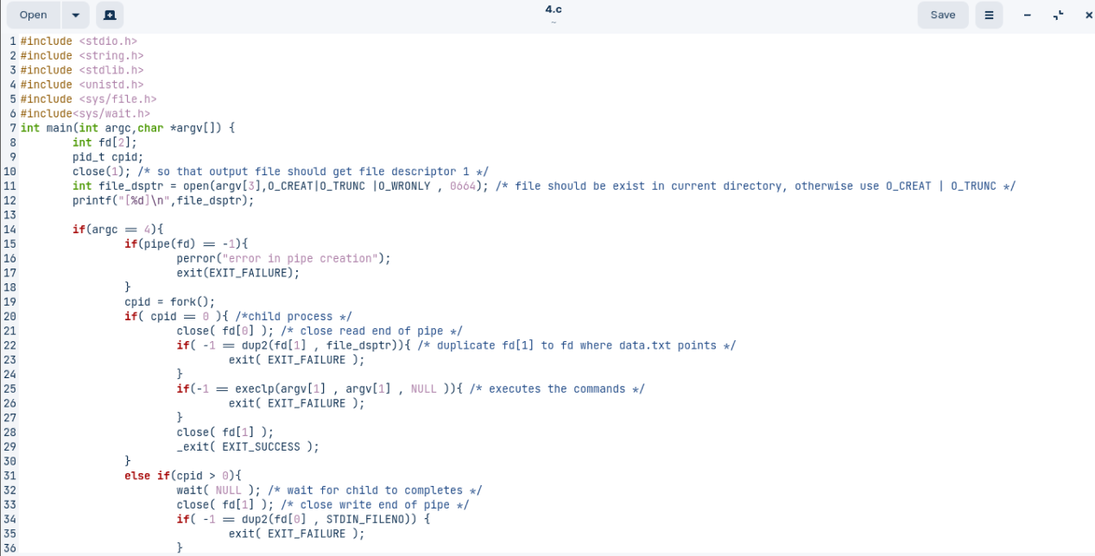

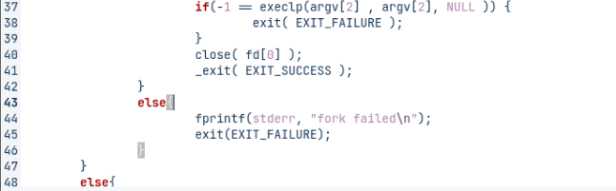

**Output:**

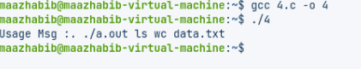

**Task2:**

**Code:**

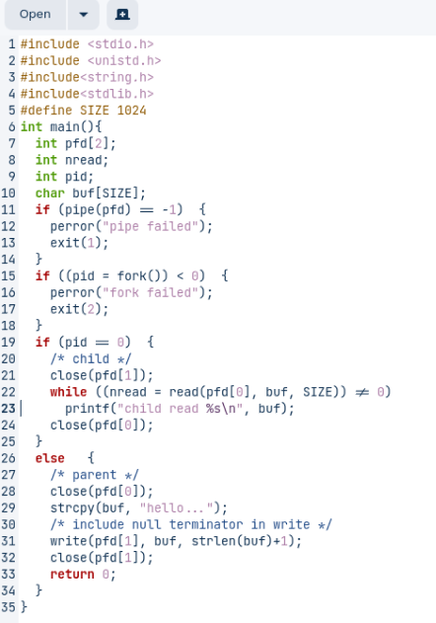

**OutPut:**

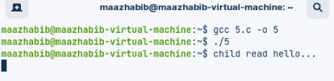

**Task 3:**

**Code:**

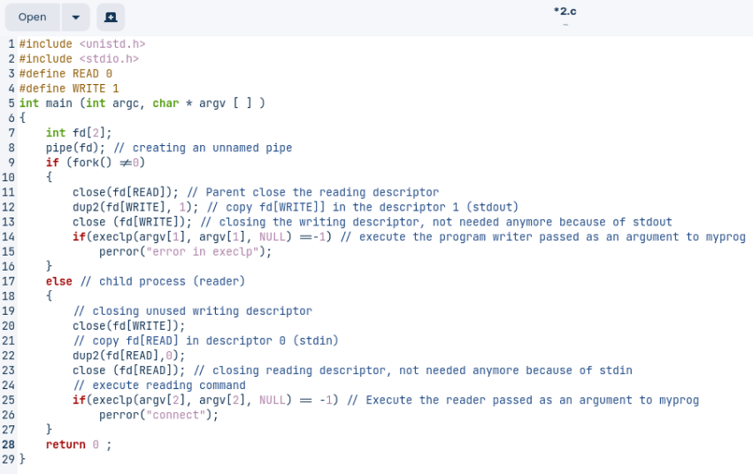

**Output:**

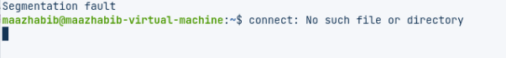

**Task4:**

**Code:**

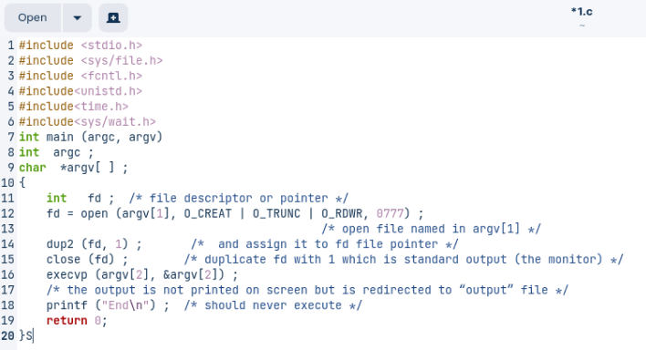

**OutPut:**

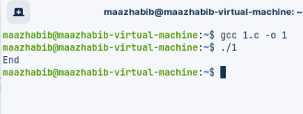

**Task5:**

**Code:**

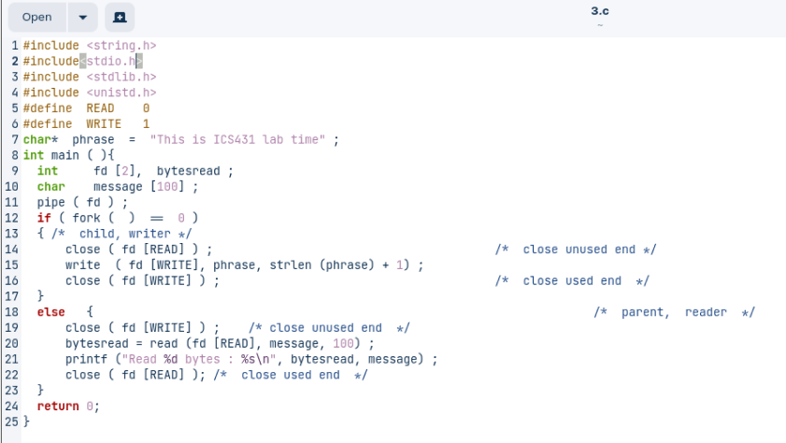

**OutPut:**

